Gaming:

DL Model

week +

product_procurement_sla +

product_mrp_class_medium +

Event_Dussehra +

Event_FHSD +

Event_Rakshabandhan + NPS_WeekAvg +

investmentDigital + investmentContentMarketing

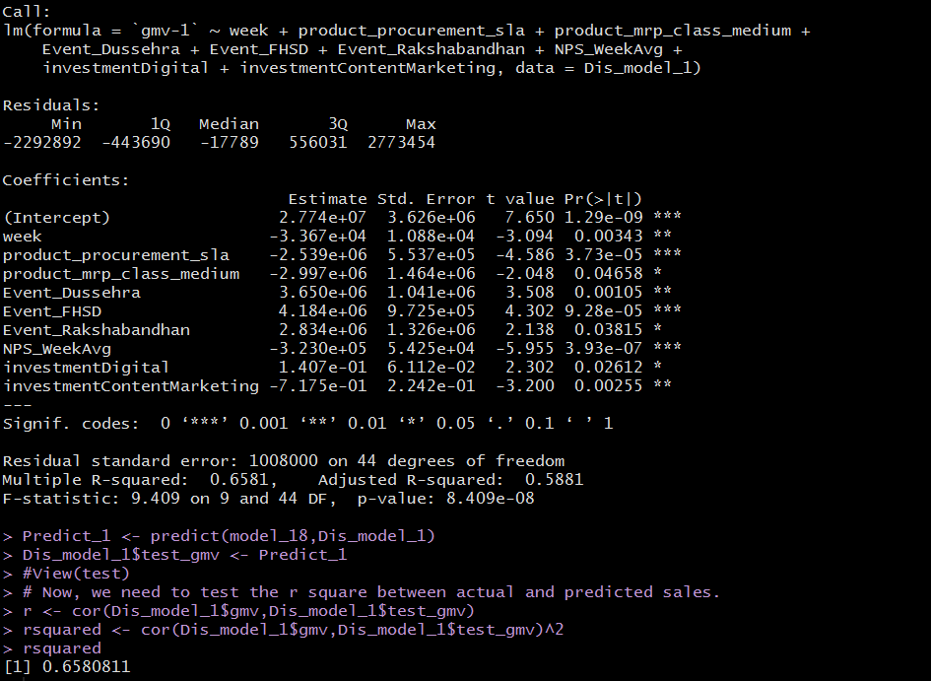

DL+Multi

Year + week +

s1_fact.order_payment_type_COD +

product_mrp_class_premium +

investmentDigital + product_mrp_class_medium +

investmentSEM + investment +

investmentRadio + investmentOther

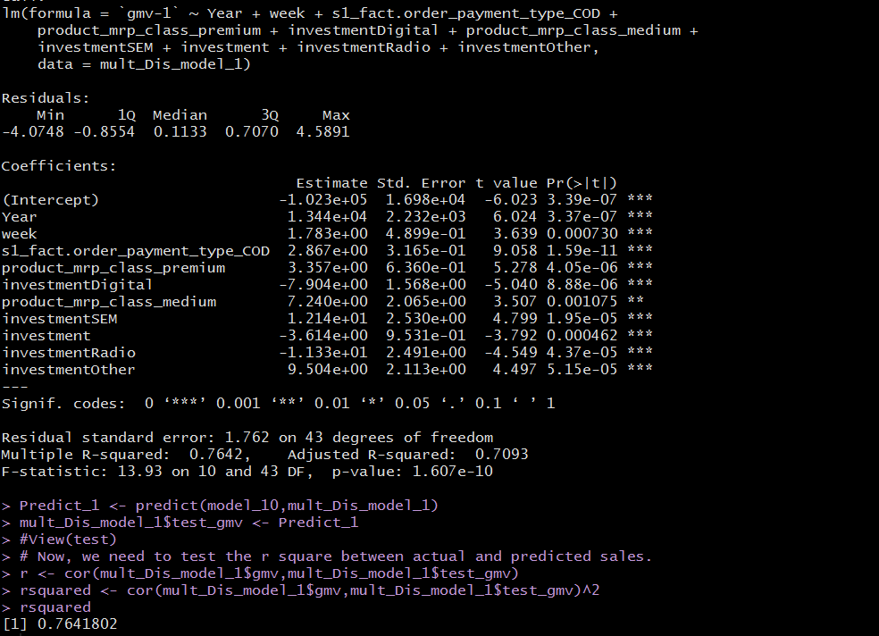

Linear model

week + deliverybdays + product_procurement_sla +

product_mrp_class_cheap + Event_BED + `Event_Christmas & New Year` +

Event_NA +

investment + investmentTV + investmentSponsorship + investmentContentMarketing +

investmentOnlinemarketing + investmentSEM + investmentRadio

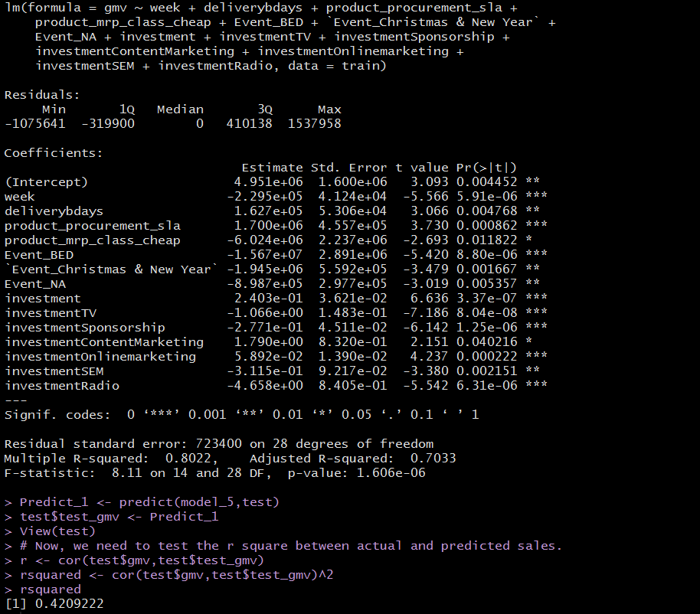

Multiplicative

**s1_fact.order_payment_type_COD +**

**investmentTV +**

**investmentOnlinemarketing +**

**investmentRadio + investmentOther**

